**CODE FOR INTERNET EXPLORER:**

package firefox;

import org.openqa.selenium.WebDriver;

import org.openqa.selenium.ie.InternetExplorerDriver;

public class IeBrowser {

public static void main(String[] args) throws InterruptedException {

//FireFox driver1;

WebDriver driver1;

//WebDriver driver1 = new ieDriver();

System.setProperty("webdriver.ie.driver","C:\\Program Files\\Java\\jdk1.8.0_131\\IEDriverServer.exe");

driver1 = new InternetExplorerDriver();

//driver2 = new ChromeDriver();

driver1.get("http://techfetch.com") ;

//driver2.get("http://techfetch.com") ;

System.out.println("Page title is " + driver1.getTitle() ) ;

//System.out.println("Page title is " + driver2.getTitle() ) ;

Thread.sleep(10000) ;driver1.quit(); ;

//Thread.sleep(10000) ;driver2.quit(); ;

}

}

**SCREENSHOT FOR OUTPUT:**

**SCREENSHOT1:**

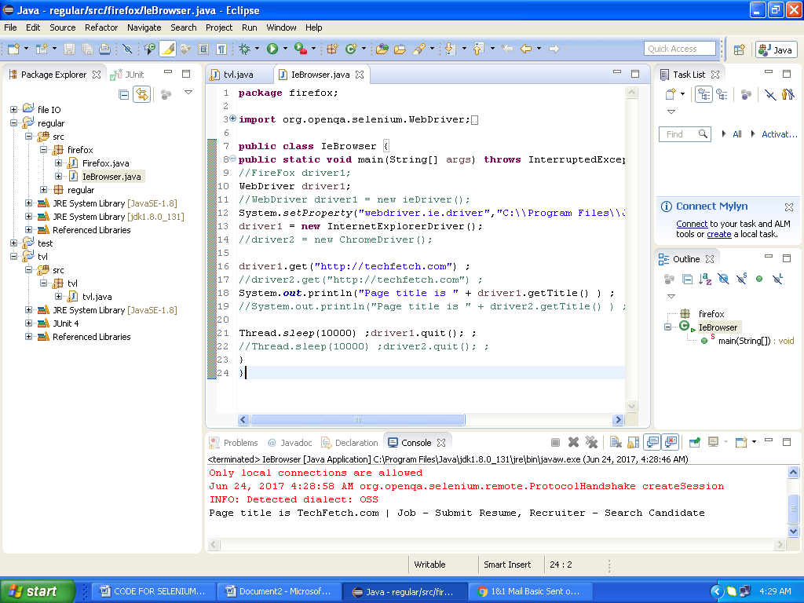

**SCREENSHOT2:**

